**PRE-BOARD EXAMINATION – I (2023 -24)**

SUBJECT: Physical Education (048) Maximum Marks: 70

CLASS: 12th Grade TIME: 3 Hours.

General instructions:

1) The question paper consists of 5 sections and 37 Questions.

2) Section A consists of question 1-18 carrying 1 mark each and is multiple choice questions. All questions are compulsory.

3) Sections B consist of questions 19-24 carrying 2 marks each and are very short answer types and should not exceed 60-90 words. Attempt any 5.

4) Sections C consist of Question 25-30 carrying 3 marks each and are short answer types and should not exceed 100-150 words. Attempt any 5.

5) Sections D consist of Question 31-33 carrying 4 marks each. Attempt all.

6) Section E consists of Question 34-37 carrying 5 marks each and are short answer types and should not exceed 200-300 words. Attempt any 3.

SECTION A

1. Considering the staircase method how many matches will be played if the total number of teams is 9 in a tournament? (1)

a) 36 b) 24 c) 42 d) 51

2. Bone Condition given in the picture below is suitable example of (1)

a) Lordosis b) Scoliosis c) Kyphosis d) Osteoporosis

3. Which among the following is a corrective measure of Lordosis. (1)

a) Pick up marbles with toes b) Practicing Horse Riding regularly c) Forcing a child to walk early d) Perform Halasana

4. In the list of below given asanas Which one is contraindicated if suffering high blood pressure.

(1)

a) Gomukhasana b) Pawan Muktasana c) Sukhasna d) Chakrasana

5. Match the following asanas with life style diseases: - (1)

(a) Diabetes - (i) Chakrasana

(b) Obesity - (ii) Ardh matsyendrasna

(c) Asthma - (iii) Makarasana

(d) Back Pain - (iv) Dhanurasana

(a) A-I, B-II, C-III, D-IV

(b) A-II, B-IV, C-I, D-

(c) A-IV, B-III, C-I, D-II

(d) A-IV, B-III, C-II, D-I.

6. Assertion (A): Diversified teaching strategies benefit all students / children with disabilities.

Reason (R): Inclusion encourages Social and communication skills of SEN students. (1)

In the context of above tow statements which one of the following is correct:

a) both (A) and (R) are true, but (R) is not correct explanation of (A)

b) both (A) and (R) are true and (R) is the correct explanation of (A)

c) (A) is true but (R) is false

d) (A) is false but (R) is true

7. Assertion (A): Physical Activities lead to cognitive skills development in a child.

Reason (R): Thinking, reasoning, and remembering are the skills that help SEN students to discover and access strength. (1)

In the context of above tow statements which one of the following is correct:

a) both (A) and (R) are true and (R) is the correct explanation of (A)

b) both (A) and (R) are true, but (R) is not correct explanation of (A)

c) (A) is true but (R) is false

d) (A) is false but (R) is true

8. Where has the resolution of celebrating International Yoga Day passed? (1)

a) World Health Organization b) Indian Parliament

c) UN, General Assembly d) International Sports Committee

9. Match list - 1 with list - 2 and select the correct code given below (1)

|  |  |  |  |
| --- | --- | --- | --- |
| `1 | Niacin / B3 | A | Production of thyroid hormone |
| 2 | Cooper | B | Blood Clotting, Bone Health |
| 3 | Vitamin K | C | Proper function of all body part such as |
| 4 | Iodin | D | Helo Iron in formation of Hemoglobin |

a) 1-C, 2-D, 3-B, 4-A b) 1-A, 2-B, 3-C, 4-D c) 1-B, 2-D, 3-A, 4-C d) 1-D, 2-A-, 3-B, 4-C

10. Identify the test item given in the picture. (1)

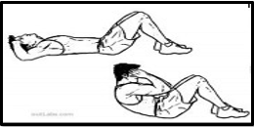

a) Sit & Reach Test b) Agility c) Partial Curl up d) Reverse Plank

11. Identity the activity performed below. (1)

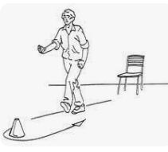

a) Chair stand test b) Six mint walk test c) Chair sit & reach d) 8 foot up & go test

12. research has found that 90% of dieters Gain all their weight back, sometime even more than that. This statement is a? (1)

a) Food myth b) Pitfalls of dieting c) Food intolerance d) Weight Management

13. Identify the test performed in the given picture. (1)

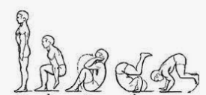

a) Forward role b) Backward role c) Summer Sault d) Standing broad jump

14. The total force of muscle depends on the number of contracting motor units is? (1)

a) Intensity of the nerve impulse b) Muscle composition which produce strength

c) Cross sectional area of muscles d) heavier person are stronger

15. Friction between skin and rough surface may lead to? (1)

a) Sprain b) Abrasion c) Contusion d) Strain

16. The section which helps to develop skills movement and resistance training in sports ic called?

(1)

a) Exercise Physiology b) Sports Training

c) Sports Biomechanics d) Sports Kinesiology

17. Which Low of motion is directly related to the picture given below? (1)

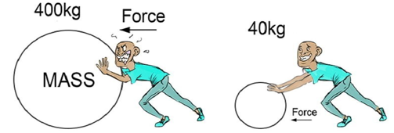

a) Low of Inertia b) Low of Reaction

c) Low of Gravity d) Low of Acceleration

18. The opposing force that comes into play when one body tends to move over the surface of another in the absence of actual motion is called? (1)

a) Center of Gravity b) Static Friction

c) Function of Lever d) Projectile

Section B

19. What is Lever? Give a brief introduction. (2)

20. Briefly explain the role of explosive strength in Speed. (2)

21. Name down any four-test item name of SAI Khelo India fitness test for age group 9-18 years / class 4-12 students. (0.5x4)

22. What is the role of non-nutritive components of diet for the Body? (2)

23. Name down any four strategies which help to make the Physical activity accessible for the children with special need. (0.5x4)

24. What is Extramural? Define it briefly? (2)

Section C

25. Write down the procedure and benefits of Hastasana. (3)

26. Compose a brief note on Scoliosis and their corrective measures. (3)

27. Briefly explain the Osteoporosis as a Female Athletics Triad. (3)

28. Write down the merits & demerits of the league tournament. (3)

29. Define friction their types and Advantage of friction in sports. (3)

30. Explain the term “Lactic Acid Tolerance” as a Factor determined Endurance. (3)

Section D

31. Fundamental under in the chart of percentage of players who suffered different kinds of sports injuries in an ongoing ICC Cricket World Cup. (4X1=4)

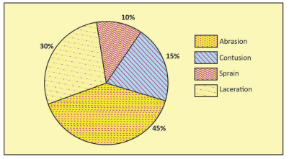

Based on the above data, answer the following questions.

a) The types of injury shown in the chart are ____________.

b) The least common injury is______________.

c) By what percentage Abrasion is more than sprain?

d) The second most common injury in the tournament is.

32. What are some common soft tissue injuries? Discuss briefly about their causes and prevention. (4)

OR

32.1 Explain in detail about the factors Determined the Flexibility.

33. In the Chart below various fitness test items are given. (4X1=4)

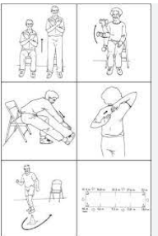

Answer the following question based on the chart.

1. Name the person who designed the Senior citizen Fitness test Battery.
2. 10x4 mtr shuttle run is helpful to measure ________.
3. Name the test to measure cardiovascular efficiency.
4. List down the SAI Khelo India fitness test item for age group 5-8 years.

Section E

34. Define Projectile and explain in detail the factors affecting it and the role of projectile in Sports. (5)

35. Draw the fixture of 17 teams using the knockout method and divide the teams into quarters / groups. (5)

36. Note down in detail the Effect of Exercise on Cardio-Respiratory System. (5)

37. Write a note on Paralympic their Aim, Objectives, Moto, Logo in detail. (5)

____________________________________